

Countries Development Analysis
World Bank Report 2024
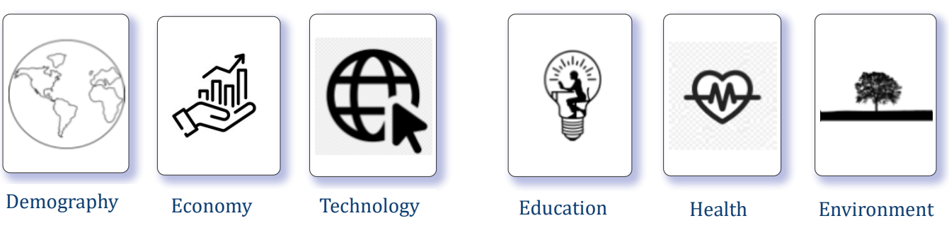

Ashool Lakhani 20221971
Francisco Oliveira 20222049
Sarah Barros 20221448
Tara Kouros 20221970

Table Of Content
Introduction ----------------------------------------------------------------------- Page 3
Data Processing ------------------------------------------------------------------------ Page 3
Relationship ------------------------------------------------------------------------ Page 5
DAX Measures ------------------------------------------------------------------------ Page 6
Visualizations ------------------------------------------------------------------------ Page 12
Population Trends ------------------------------------------------------------------------ Page 12
Labor Force Dynamics ------------------------------------------------------------------------ Page 13
Economic Indicators ------------------------------------------------------------------------ Page 14
Inflation and Poverty ------------------------------------------------------------------------ Page 14
Trade Dynamics ------------------------------------------------------------------------ Page 15
Education and Literacy ------------------------------------------------------------------------ Page 16

Introduction
DataWise, a consulting firm with a mission to unlock the potential of Information System for global development. We gathered data ranging themes from economy, health, education and more to create an analytical insight. This is not only a theoretical elaboration of global development trends but also a wide-scale representation of socio-economic parameters that includes both historical and recent social-economic indicators from year 1960 to 2024. This report provides information on global development by getting the data from carefully selected sources like World Bank. It aims to showcase essential elements of civilizational development in terms of demography, economy, technology, education, health, and environment. The report focuses on many facets of global development ranging from population dynamics to economic fluctuations, from technological advancements to environmental sustainability approaches.
The primary goals were to:
- Trace the development trajectories of nations over a significant historical period.
- Emphasize the critical shifts and milestones in global development.
- Facilitate a broad yet detailed exploration of data, inclusive of all countries.
- Draw clear comparisons between the development patterns of Developed and Developing nations.

Data Processing
Data preprocessing is an essential step in the pipeline of data analysis, which makes the data used for analysis accurate, consistent, and reliable. Importing the datasets into Power BI was the preliminary step that has to be done so as to ensure the accuracy and reliability of the analysis. This was done by clicking on "Get Data" and then selecting the preferred data source, for example Excel Workbook. After importing the datasets, they were classified into separate groups within Power BI for better management and visualization. The datasets went through cleaning processes to seclude any inconsistencies or errors. Meaningless rows and columns were to be removed, and handling of missing values was also performed properly. For datasets having superfluous rows at the bottom, a 'FilterNullAndWhitespace' step was used to automatically get rid of these rows to ensure the datasets were free from extra information. Datawise Worldbank's Report has its primary data been collected from various reliable outlets among which the World Bank must be at the top. Nevertheless, the data was supposed to be processed first with a range of preprocessing activities before actual analysis. One of the main goals of data processing was to spot the errors or inconsistencies in the data and eliminate them. Each dataset needed to be examined for a class of and outliers. The presence of outliers is known to be able to distort the analysis result. It was removed using statistical methods. Duplicate entries, if present, were eliminated since it would have been unnecessary repetition in the dataset.
Subsequently, the datasets were analyzed and the relative columns that were significant for study were identified. Indicator labels were eliminated for the columns as they were of no use for analysis. Another aspect was that all aggregate data were taken out to prevent duplication. The first row in the data set was used as a header and the years were extracted into separate rows so that each year could be represented in detail by using “Unpivot other columns”. The data types were modified to preserve the standards and make analysis more easily. After the data was cleaned, the next step was creating an organized structure so that it can be analyzed. We had to create a structure out of the information and group similar data points into extended groups in some cases. Data related to population was organized by age groups and countries, while data on labor force was grouped according to the regions. In order to simplify the analysis and improve the performance of the model, we mean datasets according to a same thematic area.
Fact Tables contain demographics, economy, health, business data, along with the correspondent country name/code and year and the Dimensional Table contains geographical information. Consistent dimensions across all fact tables played an important role in keeping the model coherent, hence, allowing accurate results in the analysis. By organizing the data in such a manner, we were able to distinguish these trends across the variables. The subsequent phase of preprocessing towards cleaning and organizing data also included checking the data's consistency and well-kept. In this context, population data was checked to make sure that the total population for a country was equal to the sum of people for each age group. Discrepancies that occurred during the validation were clarified, and only then did we continue with the analysis.

Relationship
After carefully having the tables created, we checked the existent and created new relationships between every Fact and Dimensional table with the respective cardinality : One to many.
These relationships were created using Country code due to the fact that it ensures more reliability opposed to using Country name which could have resulted in errors because of different spellings of each country.
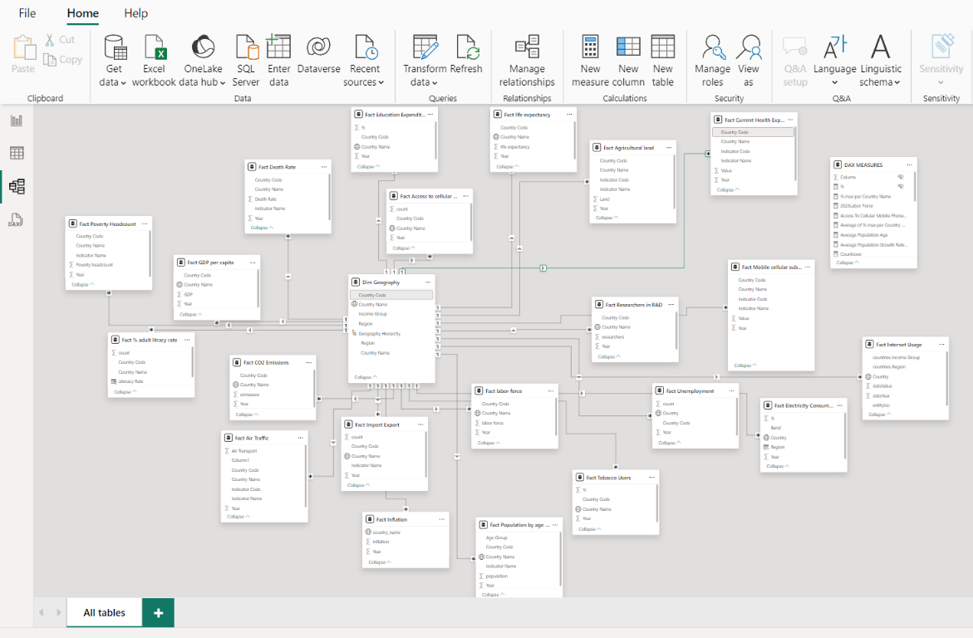

DAX Measures Utilized in Datawise Worldbank Report Analysis:
Theme | Area | DAX | Description
Education | Education Expenditure | % max per Country Name =  MAXX(  KEEPFILTERS(VALUES('Fact Education Expenditure'[Country Name])),  CALCULATE(SUM('Fact Education Expenditure'[%]))  ) | This DAX measure calculates the maximum education expenditure percentage for each country while respecting the current filter context.
Education | Education Expenditure | Min of % max per Country Name =  MAXX(  KEEPFILTERS(VALUES('Fact Education Expenditure'[Country Name])),  CALCULATE(MIN('Fact Education Expenditure'[%]))  ) | This DAX measure calculates the minimum education expenditure percentage among the maximum percentages for each country, considering any existing filters
Education | Education Expenditure | Max of % max per Country Name =  MAXX(  KEEPFILTERS(VALUES('Fact Education Expenditure'[Country Name])),  CALCULATE(MAX('Fact Education Expenditure'[%]))  ) | This DAX measure calculates the maximum education expenditure percentage among the maximum percentages for each country, considering any existing filters.
Education | Education Expenditure | Average of % max per Country Name =  CALCULATE(AVERAGE('Fact Education Expenditure'[%])) | This DAX measure calculates the average of the maximum education expenditure percentages across all countries
Demography | Population by age group | Average Population Age =  VAR TotalPopulation = SUM('Fact Population by age group'[population])  RETURN  SUMX(  'Fact Population by age group',  'Fact Population by age group'[Age Group] * 'Fact Population by age group'[population] / TotalPopulation  ) | This DAX measure calculates the average population age, weighted by the population size of each age group.
Demography | Population by age group | Min of % min per Income Group =  MINX(  KEEPFILTERS(VALUES('Dim Geography'[Income Group])),  CALCULATE(MIN('Fact % adult litracy rate'[count]))  ) | This DAX measure calculates the minimum literacy rate percentage among the minimum percentages for each income group, considering any existing filters.
Demography | Population by age group | population total for Year =  CALCULATE(  SUM('Fact Population by age group'[population]),  ALLSELECTED('Fact Population by age group'[Year])  ) | This DAX measure calculates the total population for the selected year(s) by summing the population values in the 'Fact Population by age group' table while considering the current filter context.
Demography | Population by age group | Average Population Growth Rate by Age Group =  VAR MinYear = MIN('Fact Population by age group'[Year])  VAR MaxYear = MAX('Fact Population by age group'[Year])  VAR TotalYears = MaxYear - MinYear + 1  RETURN  IF(  TotalYears > 1,  AVERAGEX(  VALUES('Fact Population by age group'[Age Group]),  (CALCULATE(SUM('Fact Population by age group'[population]), 'Fact Population by age group'[Year] = MaxYear)  - CALCULATE(SUM('Fact Population by age group'[population]), 'Fact Population by age group'[Year] = MinYear))  / CALCULATE(SUM('Fact Population by age group'[population]), 'Fact Population by age group'[Year] = MinYear)  ),  BLANK()  ) | This DAX measure calculates the average population growth rate by age group over a specified time period, provided there is more than one year in the range.
Demography | Labor Force | labor force average per Region =  AVERAGEX(  KEEPFILTERS(VALUES('Dim Geography'[Region])),  CALCULATE(SUM('Fact labor force'[labor force]))  ) | This DAX measure calculates the average labor force for each region, taking into account any existing filters.
Demography | Labor Force | 2023Labor Force =  CALCULATE(  AVERAGE('Fact labor force'[labor force]),  FILTER(  ALL('Fact labor force'[Year]),  'Fact labor force'[Year] = 2023  )  ) | This DAX measure calculates the average labor force for the year 2023, ignoring any filters on the Year column.
Technology | Access to Cellular Phone | Access To Cellular Mobile Phones Target = 80 | This DAX measure sets a target value of 80 for access to cellular mobile phones.
Environment | Electricity Consumption | Total electricity concumption per region = SUMX(  KEEPFILTERS(VALUES('Dim Geography'[Region])),  CALCULATE(SUM('Fact Electricity Consumption'[Year]))  ) | This DAX formula attempts to calculate the total electricity consumption per region.
Environment | Electricity Consumption | Countrows = COUNTROWS('Fact Electricity Consumption') | This DAX measure counts the number of rows in the 'Fact Electricity Consumption' table.
Health | Tobacco & Death | Tobacco users per region = SUMX(  KEEPFILTERS(VALUES('Dim Geography'[Region])),  CALCULATE(SUM('Fact Tobacco Users'[%]))  ) | The provided DAX formula calculates the sum of tobacco users (as a percentage) for each region by iterating over the unique regions and summing the percentages within the current filter context
Health | Life Expectancy | life expectancy per region = AVERAGEX(  KEEPFILTERS(VALUES('Dim Geography'[Region])),  CALCULATE(SUM('Fact life expectancy'[Year]))  ) | This DAX measure calculates the average life expectancy for each region, considering any existing filters.
Economy | Inflation & Poverty | Total Poverty = CALCULATE(SUM('Fact Poverty Headcount'[Poverty headcount])) | This DAX measure calculates the total poverty headcount by summing the values in the 'Poverty headcount' column of the 'Fact Poverty Headcount' table.
Economy | Inflation & Poverty | Maximum Inflation =  MAXX(  KEEPFILTERS(VALUES('Fact Inflation'[Year])),  CALCULATE(AVERAGE('Fact Inflation'[inflation]))  ) | This DAX measure calculates the maximum average inflation rate for each year, considering any existing filters.
Economy | Uneployment & Literacy | Min of % min per Income Group =  MINX(  KEEPFILTERS(VALUES('Dim Geography'[Income Group])),  CALCULATE(MIN('Fact % adult litracy rate'[count]))  ) | This DAX measure calculates the minimum literacy rate percentage among the minimum percentages for each income group, considering any existing filters.
Economy | Uneployment & Literacy | Minimum Inflation =  MINX(  KEEPFILTERS(VALUES('Fact Inflation'[Year])),  CALCULATE(AVERAGE('Fact Inflation'[inflation]))  ) | This DAX measure calculates the minimum average inflation rate for each year, considering any existing filters.
Economy | Uneployment & Literacy | Percentage of Employed =  [Measure] - AVERAGE('Fact Unemployment'[count])
Economy | Uneployment & Literacy | Percentage of Employed =  [Measure] - AVERAGE('Fact Unemployment'[count]) | The given DAX formula intends to calculate the percentage of employed individuals by subtracting the average unemployment count from an existing measure which in this case is equal to 100.
Economy | Uneployment & Literacy | percentile = PERCENTILE.EXC('Fact % adult litracy rate'[count], 0.25) | This DAX formula calculates the 25th percentile (first quartile) of the adult literacy rate percentages. The PERCENTILE.EXC function returns the k-th percentile of values in a range, where k is between 0 and 1, exclusive
Economy | Import & Export | Sum of Exports (current US$) =  CALCULATE(  SUM('Fact Import Export'[count]),  'Fact Import Export'[Indicator Name]  IN { "Exports of goods and services (current US$)" }  ) | This DAX measure calculates the sum of exports (in current US dollars) by summing the values in the 'count' column of the 'Fact Import Export' table, filtered to include only rows where the 'Indicator Name' is "Exports of goods and services (current US$)".
Economy | Import & Export | Sum of Imports(current US$) =  CALCULATE(  SUM('Fact Import Export'[count]),  'Fact Import Export'[Indicator Name]  IN { "Imports of goods and services (current US$)" }  ) | This DAX measure calculates the sum of imports (in current US dollars) by summing the values in the 'count' column of the 'Fact Import Export' table, filtered to include only rows where the 'Indicator Name' is "Imports of goods and services (current US$)".

Visualizations

Population Trends:
Population trends, which represent a nation's demographic features as a whole and its own developmental path are crucial indicators. Using population ring charts will provide a holistic picture of the age composition of different continents. In these charts, we can clearly compare the density of each age group. The colors used, blue symbolizing a younger population and green for an older group of people, highlight this separation even more.
This visualization does not only reflect the existing demographic but as well allows for the identification of trends such as a rapidly growing population or an aging population. Furthermore, using stacked column charts to show the worldwide population growth rate movement in the yearly periods' scale. Such aspects are possible to be case of demographic changes that include number of births, deaths and population movements. The population analysis through the help of visualizations like the age group ring graph and stacked column graph along with the map will provide Worldbank with a clear analysis. Addressing current and future societal issues requires understanding demographic shifts, besides, it is also required for sustainable development.
Labor Force Dynamics:
One of the main factors that determine the development of countries’ economies is labor force dynamics. In The Datawise Worldbank Report, labor force dynamics are visualized using a number of tools and techniques to offer a broad perspective on the participation of workforce and employment trends. The bar graph, as a major visualization tool, very well complements these data displaying the labor force by region in the latest year with available data(2023). The sectors with high labor force participation are quickly and easily spotted with the map , which in turn leads to an easily targeted analysis. The line chart is also used to show the labor force rate change in the last three decades as a determinant factor. Moreover, the unemployment rate line chart provides deeper possibilities for analysis. These visualizations help us in understanding long-term trends in working population, unemployment rates and the overall labor market dynamics of the world. Through this process, policymakers are able to more extensively feel out the forces of change in employment numbers and design specific and unique policies and/or initiatives to deal with challenges as well as grasp opportunities in the labor market.

Economic Indicators:
The economic indicators as essential instrument in examining the social and welfare of a country play the primary role in its economy. Apart from these indices, GDP per capita is the most important indicator of a country's standard of living and overall economic prosperity. In the Datawise Worldbank PowerBI Report, GDP per capita is shown using a line graph with the average GDP per capita yearly. Besides this, having a bar graph oriented by region to compare the GDP of different regions is essential to analyze the discrepancies. Further more, we used a map and another line chart with data of yearly trend of agriculture land to try and find correlation of this fact with the GDP.By using this visualization we could conclude that the regions with higher % of agricultural land consequently had a higher GDP per capita, (North America and Europe).
Inflation and Poverty:
The considerations of inflation and poverty entail serious economic obstacles that might harm individual’s and society’s wellbeing. In this page, the economic factors can be analyzed by a line chart with the yearly trend of the inflation rate along with an average poverty yearly trend line chart . By using the conditional formatting, the values close to the minimum and maximum within the data are highlighted and the regions experiencing pronounced inflationary pressures are pointed out.
Concurrently, a line chart is used to explain the varying relationship between inflation rises and changes in average living standards. Visually, they provide viewers with a holistic and comprehensive perception of the issues that underpin both inflation and poverty. Additionally, they allow for a thorough investigation of the complex links between inflation and poverty which in turn facilitate implementation of effective policies to achieve economic stability and poverty reduction. More specifically, we can see that in the years that had a spike of the inflation rate there was a massive effect on the poverty rate.

Trade Dynamics:
Trade Dynamics is an important determinant of the global economy which promotes growth and stimulates development. We selected a stacked bar chart to accurately demonstrate the intricacies of international trade. Through this diagram we can clearly see the structure of global exports and imports distribution on different territories which will help look at trade environment in general. Thus, the ability to distinct the trade performance of specific regions over the entire world is a great indicator. Through the development of a visual indicator, we can identify regions that are exceptional in trade as well as areas that may require development interventions. Moreover, in order to enable a better understanding of trade competitiveness, a table showing the average coverage rate of exports was added in the graphic. This is a crucial data point as it shows whether the total value of exports is bigger than the total value of imports.
Education and Literacy:
Education is a process which is crucial for the human development and social-economic development. To show education and literacy trends in the form of a line chart, the average global literacy rate was demonstrated. This chart shows that literacy level is growing with time and also shows the significance of education in human capital development. Below, another line chart was used with data of the yearly trend of unemployment so it could be correlated to the average literacy rate. With this in mind, we noted that as the literacy rate goes up, the unemployment goes down. Further more, we used a bar chart to identify which countries had the highest unemployment.
Health, life expectancy:
When it comes to health, we started by using a radar chart with the average of life expectancy of each country alongside with a line chart with the overall life expectancy trend over the years and the health expenditure per capita. This was essential to understand that the uptrend on health expenditure directly influenced the increase in life expectancy. Apart from this, we used a slicer that contains regions to deepen our analysis based on every part of the world. On the top right corner we used a card with the average life expectancy of the world to compare it to each country specifically.
Health, Tobacco Users:
The Tobacco Users and Deaths dashboard utilizes several Power BI visualizations to provide insights into the correlation between tobacco usage and death rates globally.
The line chart with the % of tobacco users over the years shows a clear downward trend in the percentage of adult tobacco users from 2000 to 2020. The second line chart tracks the average death rate from 1960 to 2020. There is also a noticeable downward trend which correlates them both. Although there was a slight uptick after 2020 which was caused by covid.
By using these two graphs alongside with the slicers and the clustered bar chart, we could easily make a correlation between these two factors by analyzing either by region or country.
Technology, internet usage:
The Internet Usage dashboard was focused to show trends in internet usage across income groups and regions. Displaying internet usage percentages: high-income countries, middle-income countries, and low-income countries. They indicate an increase in internet usage over time for all income levels, though high-income countries consistently lead. A bar chart on the right compares average internet usage by region, with North America and Europe & Central Asia having the highest usage, and South Asia and Sub-Saharan Africa the lowest. This dashboard aimed to highlight the digital divide, showing that higher income levels and regions correlate with greater internet usage. These comparisons underscore the socio-economic disparities in digital access, essential for addressing global connectivity challenges.

Technology, access to mobile phones:
The Access to Cellular Mobile Phones and Subscriptions dashboard showcases various metrics related to mobile phone accessibility and usage. A bar chart on the left compares different countries by the percentage of the population with access to cellular mobile phones and the number of subscriptions per 100 people. High-income countries like Norway and Luxembourg show near-universal access and high subscription rates.
The line chart depicting the growth in access to cellular mobile phones over the years illustrates a steep increase from almost 0% in 1990 to +-80% in recent years, reflecting rapid technological adoption. Another line chart tracks mobile cellular subscriptions per 100 people, showing significant growth.
These visualizations collectively highlight the disparity in mobile phone access between high and low-income regions, with richer nations having nearly full coverage and high subscription rates, while poorer countries stay behind. Furthermore, it underscores the importance of addressing the digital divide.
Technology, Researchers in R&D:
The Researchers in R&D dashboard provides a comprehensive look at the distribution of researchers per million people across different countries and regions and its correlation to literacy rate. The top left card shows the total number of researchers in the latest year with available data. The pie chart below illustrates the regional distribution, with Europe & Central Asia having the largest share , followed by East Asia & Pacific , and a small percentage in the Middle East & North Africa and Latin America.
These visualizations collectively emphasize that higher-income nations dominate in research capacity, supported by higher literacy rates. This highlights the disparity in research and development resources between high-income and lower-income countries, underscoring the importance of investing in education to boost research capabilities globally.
Environment, CO2 Emissions & Air transport:
The CO2 Emission and Air Transport dashboard presents data on yearly CO2 emissions and air transport metrics. The top line chart shows yearly CO2 emissions from 1990 to 2020, with a general upward trend from.
The bottom line chart illustrates yearly air transportation figures from 1970 to 2020, showing a steady increase, with a noticeable dip in 2020 likely due to the COVID-19 pandemic. Using the donut chart on the right allows us to compare each country air transport amount to the average of the world.
These visualizations collectively show that the increase of air transportation has been causing an increase of the CO2 emissions.
Environment, electricity consumption:
The Electricity Consumption dashboard provides insights into the distribution of energy consumption across different countries and consumption bands. The map on the left visualizes the percentage of energy consumption by country in Europe, highlighting geographical differences in electricity usage. The pie chart on the right displays the distribution of energy consumption by consumption bands. Higher consumption bands make up the largest portion at , while lower consumption bands constitute the smallest portion at. This indicates that a significant portion of energy consumption is concentrated in higher usage categories. The line chart at the bottom shows the average percentage of energy consumption over the years, segmented by different kWh bands. This chart reveals that higher-income countries generally have a higher percentage of energy usage in larger kWh bands, whereas lower-income countries have higher percentages in smaller kWh bands.
From these visualizations, we can conclude that more developed countries tend to consume more energy, reflected in higher percentages in larger kWh bands, while less developed countries have smaller energy consumption percentages in lower kWh bands. This dashboard effectively highlights the disparity in energy usage based on economic development levels.
Education, Government Expenditure On Education:
The Government Expenditure on Education dashboard visualizes the percentage of GDP that different countries allocate to education. The line chart shows a steady increase in average expenditure on education from 1970 to 2020, indicating a growing commitment to educational funding over the years. The bar chart ranks countries by their average education expenditure, highlighting significant differences in how nations prioritize education. This along with the cards displaying the maximum expenditure allows us to have a deeper understanding of each country compared to another. Overall, the dashboard reveals a positive trend in government spending on education, with higher percentages observed in certain countries, reflecting their prioritization of education in national budgets.
Conclusion
The Datawise Worldbank Report using Power BI provides a comprehensive overview of global development from 1960 to 2024. It highlights key trends and disparities across various socio-economic indicators, such as population growth, labor force dynamics, economic performance, education, health, technology, and environmental impact.
Overall, the report reveals consistent global population growth and economic expansion, particularly in high-income regions. It underscores the significant disparities in education, healthcare, and technological access between developed and developing countries. Furthermore, environmental data highlights the growing impact of economic activities on CO2 emissions and energy consumption.
These insights emphasize the need for targeted policies and investments to address global disparities and promote sustainable development. The value of data-driven decision-making is clear in understanding and addressing these complex global challenges.

References
World Bank. (2013). The World Bank Annual Report 2013. The World Bank.
World Bank. (1993). World Development Report 1993: Investing in Health, Volume1. The World Bank.
Government expenditure retrieved from Worldbank.org website - https://data.worldbank.org/topic/education
Electricity Consumption retrieved from https://ec.europa.eu/eurostat/databrowser/view/nrg_pc_204_v/default/table?lang=en
CO2 Emission retrieved from https://climatedata.imf.org/datasets/7cec1228bfbe4a5e876ca5a5abedd64f/explore
World Health Organization, & The World Bank. (2023). Tracking universal health coverage: 2023 global monitoring report. World Health Organization.

